**IDX G9 BIOLOGY H STUDY GUIDE ISSUE 2**

**By Edward**

**Vocabulary**

3.4

* nitrogen fixation
* denitrification
* limiting nutrient

4.1

* weather
* climate
* microclimate
* greenhouse effect

4.2

* tolerance
* habitat
* niche
* resource
* competitive exclusion principle
* predation
* herbivory
* keystone species
* symbiosis
* mutualism
* parasitism
* commensalism

4.3

* ecological succession
* primary succession
* pioneer species
* secondary succession

4.4

* canopy
* understory
* deciduous
* coniferous
* humus
* taiga
* permafrost

**3.4 Cycles of Matter (nitrogen cycle to nutrient limitation)**

*Nutrient Cycles*

The Nitrogen Cycle

* Organisms require nitrogen to make amino acids which are used to build proteins and nucleic acids (which make up DNA and RNA)
* Forms of nitrogen:
  + Nitrogen gas (N2) in atmosphere
  + Ammonia (NH3), ammonium (NH₄⁺), nitrate ions (NO3−), and nitrite ions (NO2−) in soil, waste, and dead/decaying organic matter
  + Dissolved nitrogen exists in several forms in large water bodies
* Nitrogen fixation
  + Bacteria in soil and on legume roots convert N2 into NH3/NH₄⁺
  + Lightning converts N2 into usable forms (atmospheric nitrogen fixation)
* Nitrification
  + Soil bacteria convert NH3/NH₄⁺ into NO3−/NO2−, which isusable by producers
* Assimilation
  + Plants absorb NO3−/NO2− in the soil, and convert the compounds (inorganic) into proteins and nucleic acids (organic)
* Feeding
  + Consumer eat producers and assimilate the organic compounds
* Decomposition/Ammonification
  + Decomposers release nitrogen from waste and dead organisms as ammonia, nitrates, and nitrites
* Denitrification
  + Other soil bacteria convert NO3−/NO2− back to N2 in the air
* Human factors
  + 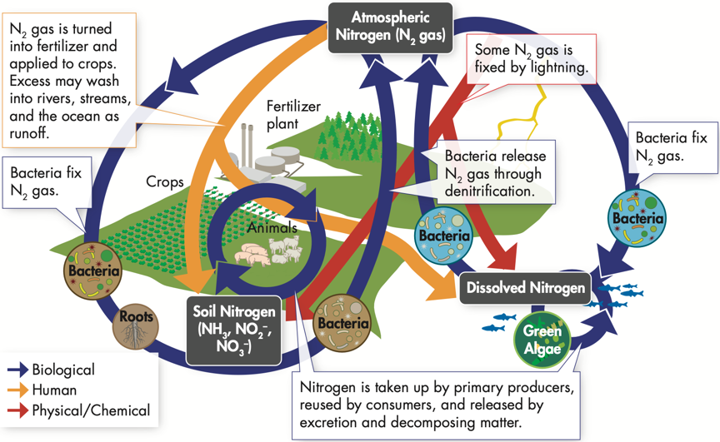Excess fertilizer is carried into surface water or groundwater by precipitation

The Phosphorus Cycle

* Phosphorus forms a part of DNA and RNA, but is not abundant in the biosphere
* Forms of phosphorus
  + Inorganic phosphate (PO43-)
    - Rock and soil minerals on land
    - Dissolved or as sediment in ocean
  + Organic phosphorus compounds in living things
* Weathering/erosion of rocks gradually releases phosphate
* Phosphate cycles between soil, producers, and consumers
* 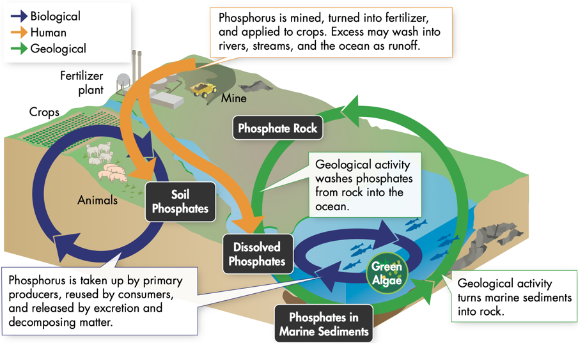Marine organisms incorporate dissolved phosphate in the ocean into compounds

Nutrient Limitation

* Availability of nutrients can limit the primary productivity of an ecosystem with ample sunlight and water
* Primary productivity
  + Rate at which primary producers create organic material (e.g., carbohydrates)
* Limiting nutrient
  + The nutrient whose supply limits productivity
* Fertilizer solves the problem of nutrient limitation in soil
* Aquatic ecosystems
  + Often nutrient-poor, with nitrogen as the limiting nutrient in saltwater and phosphorus as the limiting nutrient in freshwater
  + Large inputs of a limiting nutrient (e.g., runoff from heavily fertilized fields) can result in an algal bloom
  + Algal blooms can cover the water’s surface and disrupt the ecosystem

**4.1 Climate**

Weather

* Day-to-day condition of Earth’s atmosphere

*Climate*

* Year-after-year patterns of temperature and precipitation
* Microclimates
  + Created because environmental conditions can vary over small distances
* Factors affecting climate
  + 1. Solar energy trapped in the biosphere
  + 2. Latitude
  + 3. The transport of heat by winds and ocean currents
* Greenhouse effect
  + Solar energy (sunlight) strikes Earth’s surface
  + Some is reflected into space, some is absorbed and converted into heat (infrared radiation)
  + Some heat radiates into space, some is trapped by atmospheric gases (mainly carbon dioxide, methane, water vapor)
  + This phenomenon maintains Earth’s average temperature
  + More greenhouse gases -> more heat trapped -> Earth warms
  + Less greenhouse gases -> less heat trapped -> Earth cools
* Latitude and solar energy
  + Solar energy is intense near the equator (concentrated rays), while polar areas receive less intense solar energy (rays are spread out)
  + Unequal distribution creates the tropical, temperate, and polar climate zones
* Heat transport in the biosphere
  + Warm air (such as air near the equator) is less dense and rises, expanding and spreading north/south and losing heat along the way, sinking as it cools
  + Cool air (such as air near the poles) is denser and sinks toward the surface, pushing air at the surface outward and warming as it travels, rising as it warms
  + Earth’s rotation makes winds blow from west to east over temperate zones and east to west over the tropics and poles
  + Warm currents add moisture and heat to air, while cool currents cool air
  + Deep ocean currents are caused by cold water near the poles sinking
  + The water rises in warmer regions through upwelling

**4.2 Niches and Community Interactions**

The Niche

* Tolerance
  + Ability to survive and reproduce under a range of environmental conditions
  + Organisms experience stress outside of their optimum range of tolerance
    - Expends more energy on homeostasis, less for growth/reproduction
* Habitat
  + The place where an organism lives, determined by range of tolerance
* Niche
  + The role/position an organism has in its environment, unique to each species
  + Comprises habitat, activity patterns, resources it obtains, etc.
    - Resource: a necessity of life (e.g., water, nutrients, light, food, space)
  + Physical aspects: abiotic factors, such as water or temperature
  + Biological aspects: biotic factors, such as reproduction, diet

Competition

* When organisms attempt to use the same limited ecological resource in the same place at the same time
* Intraspecific (within the same species) or interspecific (between different species)
* Shapes ecosystem by
  + Determining number and kinds of species
  + Determining the niche each species occupies
  + Causing species to divide resources
* The Competitive Exclusion Principle
  + No two species can occupy exactly the same niche in exactly the same habitat at exactly the same time (one will outcompete the other for resources)
  + As a result, species usually divide resources

Predation, Herbivory, and Keystone Species

* Predation (in predator-prey relationships)
  + An interaction in which one animal (the predator) captures and feeds on another animal (the prey)
  + Can affect size of prey populations and where prey can live/feed
* Herbivory (in herbivore-plant relationships)
  + An interaction in which one animal (the herbivore) feeds on producers (such as plants)
  + Can affect size/distribution of plant populations where plants can survive/grow
* Keystone Species
  + A non-producer species that has a *disproportionately* large effect on its community relative to its abundance, where changes in its population can cause *dramatic* changes in the structure of a community
  + E.g., sea otters (sea urchin eaters), beavers and elephants (habitat creators)

Symbioses

* Relationships in which two species live closely together
* Mutualism (+/+)
  + Relationship in which both benefit
  + E.g., clownfish and anemone, rhinoceros and tickbird
* Parasitism (+/-)
  + Relationship in which one organism lives in/on another organism and harms it
  + Generally, parasites weaken but do not kill their host
  + E.g., Tapeworms (in host), fleas, ticks, lice, leeches, mosquitoes (on host)
* Commensalism (+/0)
  + One organism benefits and the other is neither helped nor harmed
  + E.g., barnacles and gray whales, remoras and sharks

**4.3 Succession**

Ecological Succession

* A series of more-or-less predictable changes that occur in a community over time
* Primary Succession
  + The establishment of a community in an area of exposed rock that does not have any topsoil
  + Early stages can be very slow
  + Pioneer species
    - The first species to colonize barren areas
    - Lichen (a mutualistic symbiosis between a fungus and an alga) fix atmospheric N2, break down rock, add organic material to form soil
    - Mosses: simple plants
  + Ferns/herbs/small shrubs come in and change the environment further
  + Trees come in, and their leaves provide shade and a cooler temperature
  + Over time, more and more species find a suitable niche and survive
  + Primary succession often follows:
    - Volcanic explosions creating new land or sterilizing existing areas
    - Retreating glaciers leaving only exposed bare rock
* Secondary Succession
  + Occurs where existing communities are not completely destroyed by disturbances
  + Proceeds faster than primary succession
  + Seeds, roots, and soil present
  + Secondary succession often follows:
    - Wildfires that destroy lots of plants but stimulate seed growth
    - Hurricanes or other natural disturbances
    - Human activities like logging and farming

Climax Communities

* Ecological communities in the final stage of succession, in which the species composition is relatively stable
* Natural disturbances are common in many communities, and secondary succession in healthy ecosystems following them often reproduce the original climax community

**4.4 Biomes**

Major Biomes

* Regional climates can often be affected by proximity to oceans or mountain ranges
  + E.g., cold/warm ocean currents, leeward/windward side of a mountain
* Biomes are described in terms of abiotic factors like climate and soil type, and biotic factors like plant and animal life

1. Tropical Rainforest

* Tall trees form a dense covering called a canopy 50-80m above the forest floor
* Below, shorter trees and vines form a layer called the understory
* Abiotic: high precipitation; nutrient-poor soil
* Plant life: large leaves maximize sunlight in understory, tall trees have buttress roots, epiphytic plants grow on branches of tall trees (commensalism)
* Animal life: camouflage / color-changing / climbing / jumping / flight adaptations

2. Tropical Dry Forest

* Rainy and dry seasons, droughts follow periods of rain
* Abiotic: warm year-round; rich soil
* Plant life: deciduous, waxy leaves, and store water in tissues to survive dry seasons
* Animal life: enter estivation (≈ hibernation) or migrate during dry seasons

3. Tropical Grassland / Savanna / Shrubland

* Medium-low rainfall, spotted with isolated trees and small groves
* Abiotic: warm; seasonal rain; compact soils; frequent fires
* Plant life: deciduous, waxy-leaved plants, unappetizing grass due to high silica
* Animal life: Migrate or burrow and remain dormant in dry seasons

4. Desert

* Abiotic: low precipitation; varying temp.; mineral-rich, organic-material-poor soil
* Plant life: store water in tissues, minimize leaf surface area, only open pores at night
* Animal life: often nocturnal, large ears and other extremities to lose body heat

5. Temperate Grassland

* Abiotic: seasonal temperature change; moderate rain; fertile soil; occasional fires
* Plant life: resistant to grazing and fire, seed dispersal by wind
* Animal life: constant threat of predation, may use camouflage and burrowing

6. Temperate Woodland and Shrubland

* Large areas of grass and wildflowers interspersed with trees
* Abiotic: hot dry summers; cool moist winters; thin, nutrient-poor soils; periodic fires
* Plant life: waxy leaves, fire resistant
* Animal life: browsers (varied diets of vegetation), camouflage is common

7. Temperate Forest

* Fertile soils rich in humus, a material formed from decaying leaves and other organic matter
* Abiotic: cold / moderate winters; warm summers; year-round precipitation; fertile soil
* Plant life: deciduous trees go dormant in the winter, conifers have needle-shaped wax-coated leaves to minimize water loss
* Animal life: many hibernate or migrate, others have camouflage in the winter

8. Northwestern Coniferous Forest

* Abiotic: mild temp; cool dry summers; abundant rain out of summer; rocky acidic soil
* Plant life: low diversity, lush, dense plant growth, tall trees
* Animal life: camouflage, browsers

9. Boreal Forest

* Abiotic: long cold winters; short mild summers; moderate precipitation; high humidity; acidic, nutrient-poor soils
* Plant life: conifers’ conical shape sheds snow, dark color absorbs heat, waxy leaves
* Animal life: extra insulation in fat / downy feathers or migrate for winter

10. Tundra

* Permafrost, a layer of permanently frozen subsoil, limits plant height
* Abiotic: strong winds; low precipitation; short and soggy summers; long, cold, dark winters; poorly developed soils; permafrost
* Plant life: mosses and other plants grow low to avoid strong winds, legumes have nitrogen-fixing bacteria to adapt to poor soil, seed dispersal by wind is common
* Animal life: many migrate to avoid winters, year-round residents have adaptations such as natural antifreeze, small extremities that limit heat loss, and a varied diet

Other Land Areas

* Mountain ranges and polar ice caps are not easily defined in terms of a typical community of plants and animals and are not usually classified into biomes
* Mountain Ranges
  + Exist on all continents, in many biomes
  + Conditions (temperature, wind, soil, organisms, etc.) vary great by altitude
* Polar Ice Caps
  + Polar regions, border the tundra and are cold year-round
  + Few plants, though sometimes algae grow on snow and ice
  + Seasonal mosses and lichens
  + Animals include marine mammals, insects, and mites